An Operating System (OS) is a program that manages the computer hardware. It also provides a basis for Application Programs and acts as an intermediary between computer Users and computer Hardware.

Types of OS:

- Batch OS

- Time-sharing OS

- Distributed OS

- Network OS

- Real-Time OS

- Multi Programming/ Processing/ Tasking OS

Goals of OS:

i) Convenience

ii) Efficiency

iii) Both

Functions of OS:

- It is an interface between User & Hardware

- Allocation of Resources

- Management of Memory, Security, etc.

A modern general-purpose computer system consists of one or more CPUs and a number of device controllers connected through a common bus that provides access to shared memory.

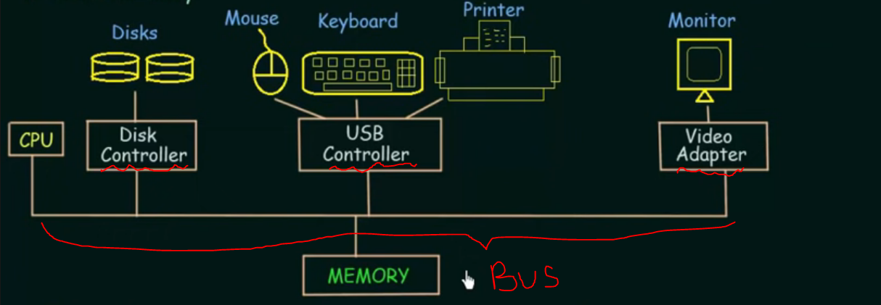

To ensure orderly access to the shared memory, a memory controller is provided whose function is to synchronize access to the memory

1) Bootstrap Program:-

- The initial program that runs when a computer is powered up or rebooted. - It is stored in the ROM.

- It must know how to load the OS and start executing that system.

- It must locate and load into memory the OS Kernel.

2) Interrupt:

- The occurence of an event is usually signalled by an Interrupt from Hardware or Software.

- Hardware may trigger an interrupt at any time by sending a signal to the

CPU, usually by the way of the system bus.

3) System Call (Monitor call):

- Software may trigger an interrupt by executing a special

operation called System Call.

When the CPU is interrupted, it stops what it is doing and immediately transfers execution to a fixed location.

→ The fixed location usually contains the starting address where the Service Routine of the interrupt is located.

→The Interrupt Service Routine executes. On completion, the CPU resumes the interrupted computation.

→Service Routine is the work required by the Interrupt.

STORGE STRUCTURE

